Project 2

Ashley Roselius

Mateen Rizki

CS 6830

**Arrival Data:**

The average interarrival time is very short for my data. The average interarrival time is under a minute and a half. The data starts off with a lot of cars coming in very close together and less and less the longer the interarrival time is. I chose to use the Exponential distribution. The text book has the exponential distribution having possible applications of interarrival times of “customers” to a system that occur at a constant rate. Between this and the fact that it looked like an exponential function I chose this. I tried a few other functions but none of them fit as well. I used the goodness of fit Chi Squared test. This test gave me a p value of 0.9963580834339701 and a statistic value of 0.17574545946607278. Since our test statistic is less than our critical value, we accept the distribution.

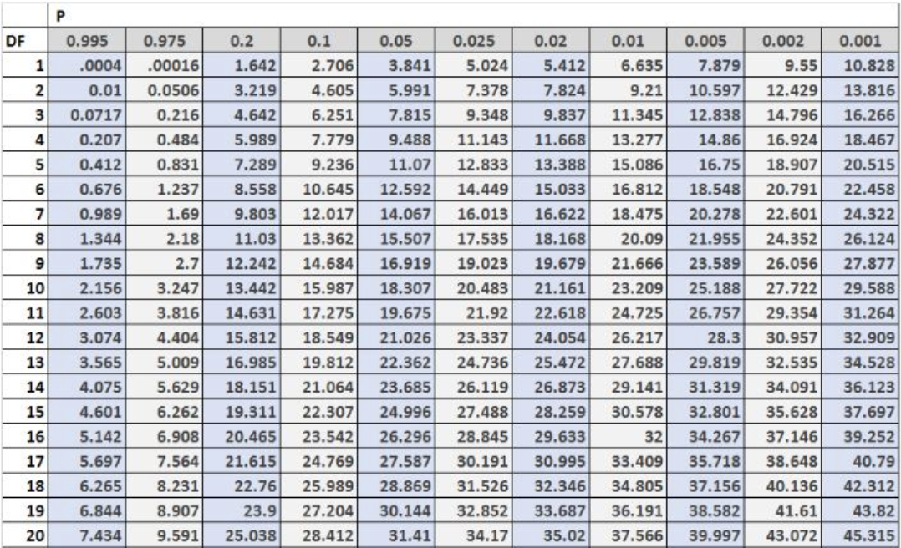

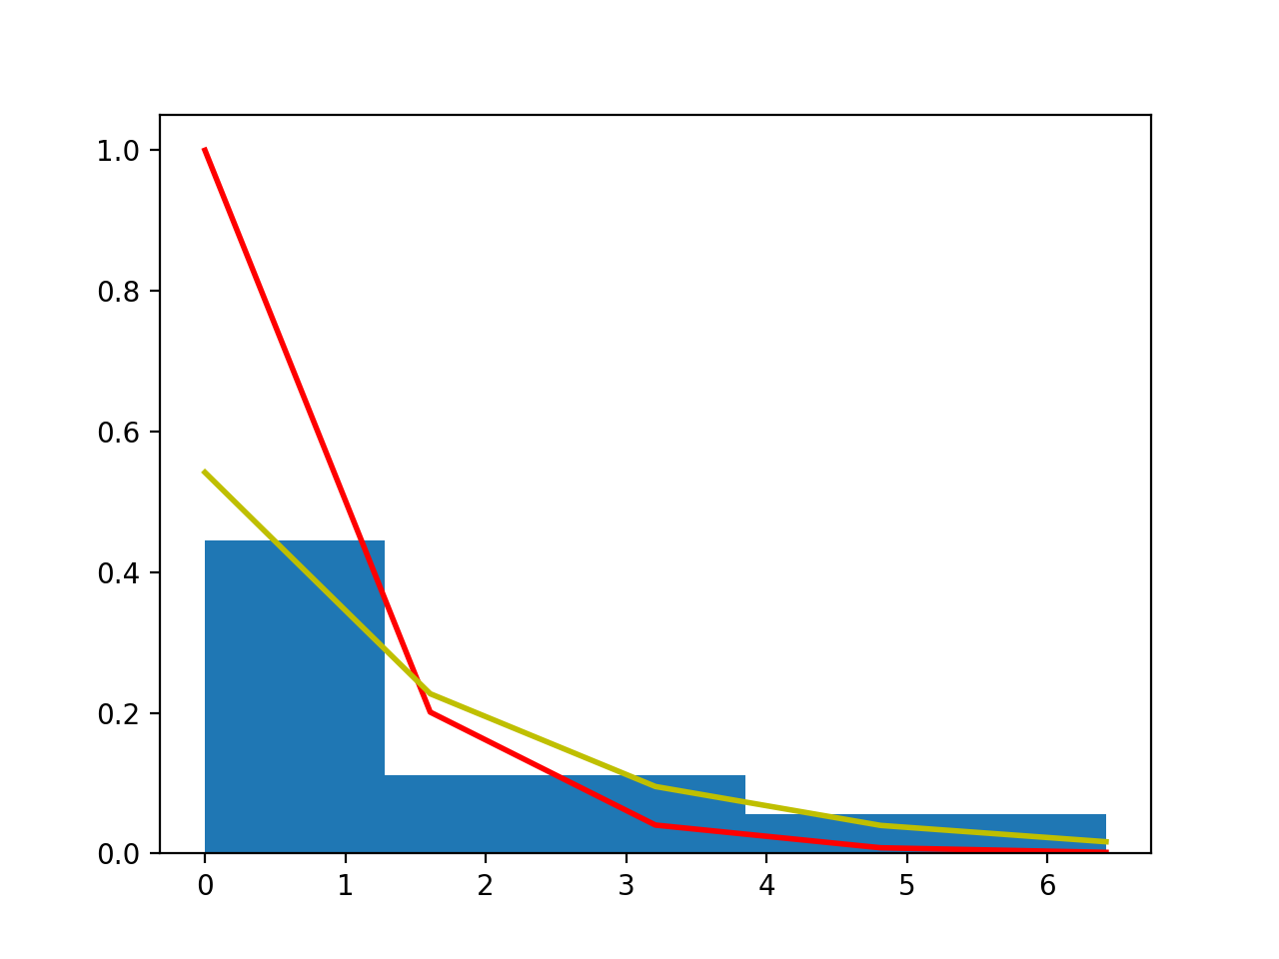

**Order Data:**

The average order time is very short for my data. The average order time is under about a minute. The data starts off with a lot of quick orders and very few the longer the order time is. I chose to Use the Gamma distribution. The text book has the gamma distribution having possible applications of time to complete some task, e.g., customer service. I tried many other functions but none of them fit as well as the gamma function did so I chose the gamma function. I used the goodness of fit Chi Squared test. This test gave me a p value of 0. 08154936020867984and a statistic value of 15.358432261156167. Since our test statistic is less than our critical value, we accept the distribution.



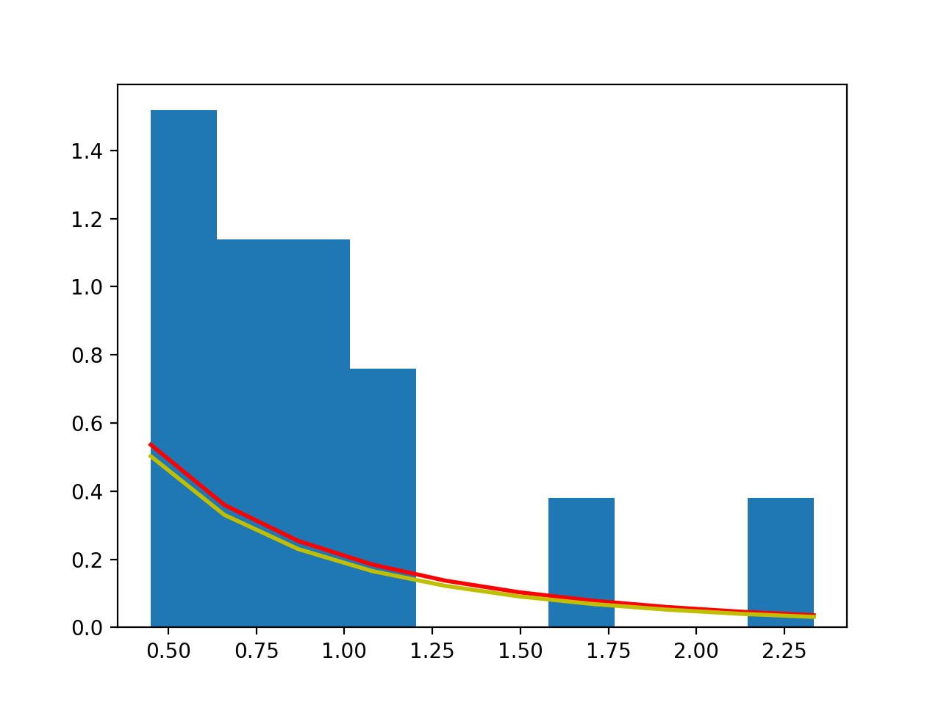

**Payment Data:**

The average payment time is in the middle for my data. The average payment time is between a half and one minute. The data starts off with a few quick payment times then a lot of middle range payment times and a few longer payment times. I chose to use the Lognormal distribution. The text book has the Lognormal distribution having possible applications of time to perform some task. I tried many other functions but none of them fit as well as the lognormal function did so I chose the lognormal function. I used the goodness of fit Chi Squared test. This test gave me a p value of 0. 5319723832323264a statistic value of 3.1565802963291363. Since our test statistic is less than our critical value, we accept the distribution.



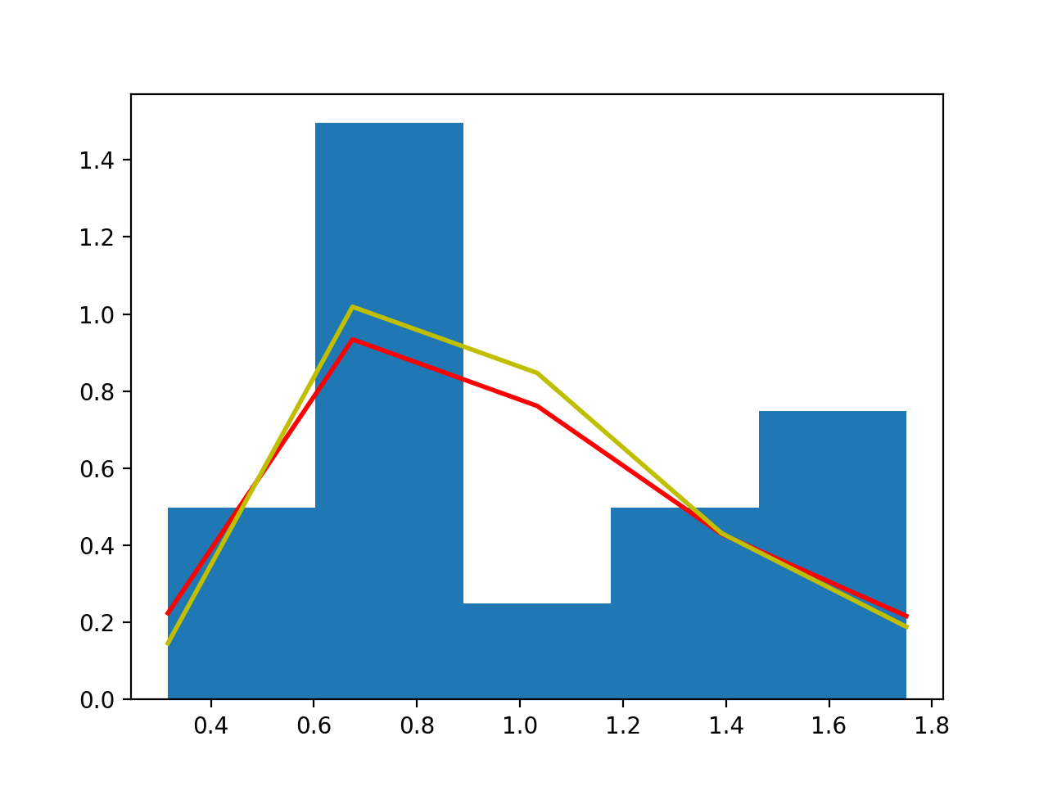

**Pickup Data:**

The average pickup time is very short for my data. The average pickup time is less than two minute. The data starts off with a most of the pickup times being quick and a few longer pickup times. I chose to use the Exponential distribution. The text book has the exponential distribution having possible applications of interarrival times of “customers” to a system that occur at a constant rate. I tried many other functions but none of them fit as well as the exponential function did so I chose the exponential function. I used the goodness of fit Chi Squared test. This test gave me a p value of 0.9813560437658274statistic value of 0. 41350865237572054. Since our test statistic is less than our critical value, we accept the distribution.



